Experiment:28 Date:18/08/2027

BEST FIRST SEARCH

Aim
To write a Prolog program to implement the Best First Search algorithm.

Algorithm
- Start from the initial node.
- Assign heuristic values to the available nodes.
- Select the node with the lowest heuristic value.
- Expand the selected node and continue searching.
- Stop when the goal node is reached and display the path.

Program
edge(a, b).
edge(a, c).
edge(b, d).
edge(b, e).
edge(c, f).
edge(c, g).

heuristic(a, 6).
heuristic(b, 4).
heuristic(c, 2).
heuristic(d, 1).
heuristic(e, 5).
heuristic(f, 3).
heuristic(g, 0).

best_first(Start, Goal, Path) :-
search([[Start]], Goal, Path).

search([[Goal|Rest]|_], Goal, Path) :-
reverse([Goal|Rest], Path).

search([[Current|Rest]|Others], Goal, Path) :-
findall(
[Next,Current|Rest],
(edge(Current, Next),
\+ member(Next, [Current|Rest])),
NewPaths
),
append(Others, NewPaths, AllPaths),
sort_paths(AllPaths, Sorted),
search(Sorted, Goal, Path).

sort_paths(Paths, Sorted) :-
predsort(compare_paths, Paths, Sorted).

compare_paths(Order, [A|_], [B|_]) :-
heuristic(A, HA),
heuristic(B, HB),
compare(Order, HA, HB).

OUTPUTS:
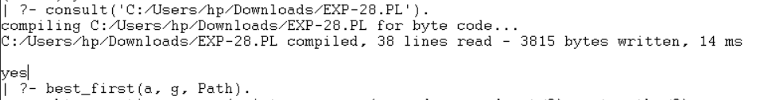

RESULTS:
Thus, the Best First Search algorithm was successfully implemented in Prolog.

